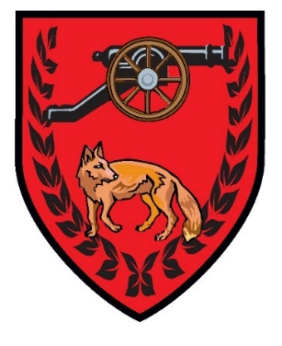
EAST GOSCOTE PARISH COUNCIL

Rules for the use of the Tennis Court,
Long Furrow, East Goscote

- Application for the use of the tennis court is open to all.

- An application form, available from the Parish Office, must be completed and an annual fee, per member, of £10 for Residents, £15 for Non-Residents must be paid at this time.
- Any misuse of the booking system or the court will result in the membership being withdrawn, and no further booking will be allowed on this membership.
- The court can be booked in one hour periods, with a maximum of two consecutive hours. Bookings can be made no more than two weeks in advance.

- Booking of the court must be made on the Parish website at www.eastgoscotepc.org.uk. Further details of this are available from the office when completing the application form.

- Appropriate footwear only allowed on the court. NO FOOTBALL BOOTS.

- Under 11s must be accompanied by an adult.
- Priority reservations will be given to Broomfield Primary School during term time.

- For safety reasons the Parish Council reserve the right to close the court during periods of inclement weather.

YOU WILL BE LIABLE FOR ANY DAMAGE INCURRED IF YOU DO NOT ENSURE THE COURT IS SECURE AFTER USE, EVEN IF THERE ARE PEOPLE WAITING TO PLAY.

Liz Pizer, Clerk

