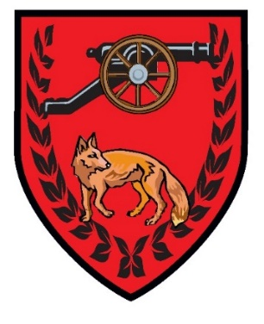
EAST GOSCOTE PARISH COUNCIL
MEMBERSHIP RENEWAL FORM
TENNIS COURTS

I am happy for you to continue holding my personal data and to communicate with me regarding tennis court activities by way of:
Post Telephone Email

Name ……………………………………………………………………………………………………………………………………………..
Email ………………………………………………………………………………………………………………………………………………
Membership Number ……………………………………………………………………………………………………………………….

I agree to abide by the Rules & Regulations set out by East Goscote Parish Council and enclose an annual fee of £10 for Residents, £15 for Non-Residents.

Signed ……………………………………………………………………………………….. Date ………………………………………………..

Office Use Only
Payment Amount Received …………………………
Date …………………………………………………………….

