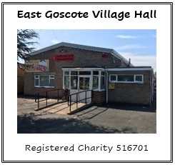
East Goscote Village Hall Management Committee
Long Furrow
East Goscote
Leicester
LE7 3ZL

Tel/Fax: 0116 260 2202
Email: EGadmin@talktalk.net

APPLICATION TO BOOK THE HALL

NAME: ______________________________________________________________________________

ADDRESS: ______________________________________________________________________________

______________________________________________________________________________

POSTCODE: ______________________________________________________________________________

TEL NO.: ______________________________________________________________________________

EMAIL: ______________________________________________________________________________

DATE REQUIRED: _____________________________________________________________________________

TIME (this includes set up / clean up FROM: ________________________ TO: _________________________

REASON FOR BOOKING: _______________________________________________________________________

I HAVE RECEIVED TERMS AND CONDITIONS / CLOSING CHECKLIST

We are required to hold certain information to fulfil our service and obligations. We will hold your Name, Address, Telephone Number and Email Address.
I HAPPY FOR YOU TO HOLD AND MAINTAIN MY PERSONAL DATA

Full payment for the hall hire must be made at the time of the booking either in cash or via bank transfer to EAST GOSCOTE VILLAGE HALL FUND, Account Number: 37171809, Sort Code: 09-01-54
We require a £40 cash damage waiver which will be returned in full after the booking and a £20 cash cleaning fee when collecting the keys prior to the booking.
Please see the terms and conditions for the cancellation policy.
I UNDERSTAND THE PAYMENT TERMS

THE COMMITTEE’S DECISION IS FINAL

SIGNED _______________________________________________________ DATE _____________________
___________________________________________________________________________________________Office Use Only
Full Cost: _______________
Date booking form received: _________________________ Date payment received: ___________________

