East Goscote Village Hall Annual Report | April 2021
Nick Shivers elected as Chairman  Rosemary Fraser elected as Vice Chairman  Lovely new blinds were fitted throughout the village hall in March 2020.  A New Baxi Boiler was fitted in our kitchen, which is energy efficient in July 2020.  Grants applied for – Our Village hall has been successful in claiming COVID grants from Charnwood Borough Council. To date we have received grants totalling £22,740.00  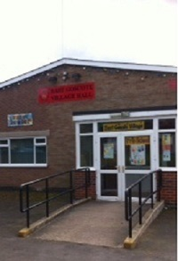  In July 2020, the hall had a new LED car park light and two new lights over the front sign. | New Composite extra secure Kitchen Door fitted in November 2020  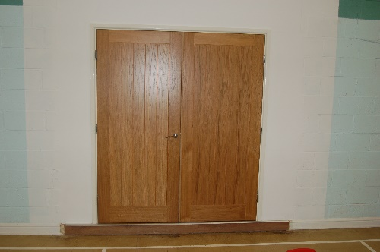  In September 2020 the old storage area doors were removed and a set of new oak doors fitted which modernises the look of our hall  Investing in our hall – our records show that £17,027 was invested in 2019. In 2020 a further £6828 was spent. These figures are based on building maintenance work only. This is an amazing achievement for the hall.  In February 2021, the kitchen was upgraded with new cutlery, pots and pan, drinks jugs and a new double oven for our users.  Building works also took place to the brickwork above the Council office door.
COVID | April 2021
From March 20 the hall was closed in line with government Guidelines.  When is was possible to open, we allowed our regular groups back into the hall.  Currently the hall is in use by our pre-school pocket rocket who open 5 days per week.  after March 2021 we hope to be able to offer our facility once again to our regular groups and residents.  thanks to everyone who hires the hall especially our regular uses who are:  Pocket rocket preschool  Brownies  guides  zumba  the Christian church group  Tetsudo  OUR THANKS  A lot of hard work is carried out to keep improving our hall, and making it such a wonderful facility for our village.  Our committee is now small, but hard working. Thanks go to:  Liz Pizer - Village Hall Manager  Nick Shivers – Chair  Rosemary Fraser – Vice Chair  Margaret Garner  Robyn Hill | For the Year Ahead  We are looking at the upgrading of both our toilets with new sinks and vanity units.  We are also working on replacing a large area of flat roof, above the kitchen.  The committee will work to continue to offer the excellent facility that is the East Goscote Village Hall  