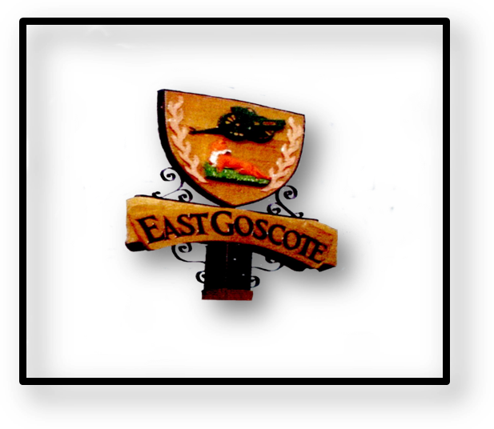
Borough Councillor
Annual Report
To
East Goscote Parish Council
2015

BOROUGH COUNCILLORS ANNUAL REPORT 2015

East Goscote Parish Library:
On 18th June 2014 The County Council held a public meeting in the East Goscote Village hall and announced that there was a proposal to withdraw funding from 36 libraries but to enable community groups to continue to run the 36 libraries that were in danger of closing due to a reduction in funding – East Goscote was one of those libraries facing possible closure. It was stated at this meeting that “if no partnership body comes forward, the library may have to close and a weekly mobile library service would replace the current provision” There would also be an online library service which was available
The Parish Council decided to conduct a resident survey regarding the library. This survey was sent to every household, was available to answer on the Parish council website, in local shops, the parish council offices and in the library itself. It was carried out in August 2014 and responses were required by 5th September 2014. A reminder of this consultation also appeared on the front cover of the Long Furrow Magazine. A total of 269 responses were received which is 9.4% of the population (2866) based on the last census count in 2011. Cllr. John Malpus called a meeting of resident volunteers and to date has over 17 volunteers who would be willing to staff the library. Cllr. Malpas has also since arranged for a management committee to be established and a meeting to formally create this committee will be held in the Village Hall later this April. I am very pleased to have been accepted as a member of that committee.
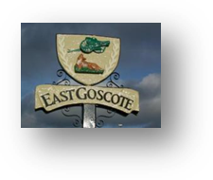
East Goscote Parish Council:
I wrote about the Parish Council in my last report (Long Furrow Magazine) having some problems due to a number of Councillor’s resigning, the Parish Clerk off on long-term sick, and eventually, the Admin Assistant also leaving. In an effort to keep the Parish Council offices opened and functioning as best it could under the circumstances, I returned to work there for a while until the anticipated return of the Parish Clerk. However, things became quite dire, unpaid bills, salaries, and the possibility of NO Christmas Event for the children of the village, so I felt I was left with no choice but to approach Charnwood Borough Council for support. Due to the low number of remaining Councillors the Parish Council was no longer ‘Quorate’ which meant that the business of the day could not be actioned any longer and that the Council was unable to function. There were only 3 Councillors left and a minimum of 4 Councillors are needed to make decisions and conduct ongoing business. Under Local Government and the Borough Council’s Constitution, the Returning Officer, Chief Executive Geoff Parker, can appoint people to act as Parish Councillors until the number returns to a position where the Council can act in the usual manner. To this end, I myself volunteered to became a Parish Councillor along with 2 other Borough Councillors on a temporary basis until the next scheduled Parish Elections (May 7, 2015) or until the number of Parish Councillors returns to a level where a ‘Quorum’ can be established through elections or co-options. Very recently, and once again functioning as a Council, the Parish Council has been able to make a start on co-opting new Parish Councillors. It is important that the Parish Council continues to function and serve its residents. Having played my part in helping to reform the Parish Council and to get it up and running once more, I decided to step down and concentrate on representing the village and its residents as their Borough Councillor. It is my intention however, to reapply for the position of Parish Councillor in May so that I can help in the management of the library and keep this valuable facility for the village.
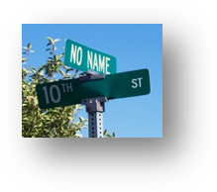
Street Name Plates:
Following a concern about street and road signage especially at Weavers Wynd and the state of some other road signs in the village, I arranged for an Enforcement Officer from Charnwood Borough Council to accompany myself and Nick Shivers (Village Caretaker) to do a rekki around the village on Wednesday 3rd September last year. As a result several improvements have been made. Weavers Wynd have had a few new signs added &/or moved to better positions and all numbered along the route so that anyone visiting a house will know exactly where to find it. The sign on the Melton Road indicating Chestnut Way was moved to its correct position onto Chestnut Way and both of the signs on either side of that road have been enlarged. Others also have new name plates: Fox Hollow, Badgers Corner, The Chase and Farriers, for example.
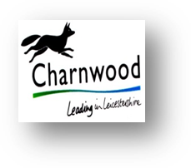
Reaccreditation to the Member Development Charter:
Charnwood Borough Council was inspected on 11th November 2014 to see whether it would be reaccredited to the East Midlands Member Development Charter. As a Member of the Member Development Group I was one of those interviewed. The Charter sets out good practice standards for member development which the Council was inspected against. The Council was first awarded the Charter in 2011 and I am very pleased to say that the inspectors decided after their visit that the Council should be re-awarded the Charter.

Section 106 Funding:
The Scrutiny Management Board (CBC) proposed that a scrutiny panel be formed to look at issues surrounding Section 106 funding. 17 Councillors showed an interest in this panel and 8 were eventually selected of which I was one. At our first ‘informal’ meeting no September 8th, it was agreed that over the next 3 scheduled meetings the panel would ask witnesses and officers to attend so that we could get background information on how the process works, what are opportunities for Ward Councillor involvement, how needs are assessed, among several other items. The Panel were to concentrate on the effectiveness of the process and whether or not the views of community groups, local parish/town and borough councillors are adequately engaged.
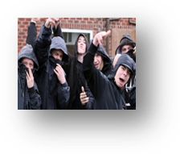
Hub Helps Tackle Anti-Social Behaviour:
Agencies are working closer than ever to tackle anti-social behaviour in Charnwood. CBC and its partners have formed the Anti-Social Behaviour Hub which is based at the council’s offices in Loughborough. It brings representatives from all agencies together to make sure information is shared efficiently and solutions can be found as quickly as possible to help victims who are suffering at the hands of others. The creation of the hub comes as the Anti-social Behaviour Crime and Policing Act takes effect. The act introduces simpler, more effective powers to tackle anti-social behaviour. It also creates a “community trigger” which gives victims and communities the right to require action to be taken where they believe an ongoing problem has not been adequately addressed.
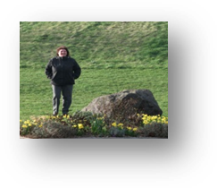
The Mound - Update:
On October 20th last year, I received a message from CBC assuring me that they have not forgotten about the Mound in East Goscote and that they are regularly monitoring the condition of the slopes. They will also continue to make repairs as and when required.

Borough Councillor Allowances:
At the Full Council Meeting last May a vote was taken on whether or not Councillors should accept a proposed 1% increase on expenses. Of the 53 Borough Councillors only 40 turned up to vote. The Labour Party Group insisted it was to be an individually named vote. 23 Tories & Libs Dems voted in favour of the increase (Increase carried). 14 Lab, 1 Independent and I voted against the increase. There were 3 Abstentions: 2 Tories & 1 Lib Dem Councillor.
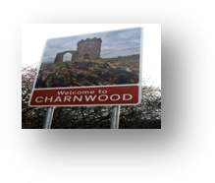
Charnwood Core Strategy:
The Core Strategy outlines how the borough could grow in terms of new homes up to 2028. More than 3,200 comments were received by Charnwood Borough Council during a major consultation on a plan which outlines how the borough will be shaped over the next 15 years. Charnwood Borough Council has put together its Local Plan Core Strategy and asked residents to comment on the soundness of the plan. CBC’s Core Strategy has since passed a significant milestone. The Planning Inspector has written to the Council to say that the Core Strategy can move forward. Mr Ward, who has been examining the strategy, says in his letter that the Core Strategy is unsound, but can be made sound with some modifications. Mr Ward has been examining the Core Strategy and conducted four weeks of public hearings at Loughborough Town Hall. The options available to Mr Ward included rejecting the Core Strategy or asking for modifications. A third option was to declare it sound as it is. After the Inspector’s modifications have been received by the Council, a consultation will be held. Mr Ward will then consider the comments received during that consultation before finalising his report for the Council.
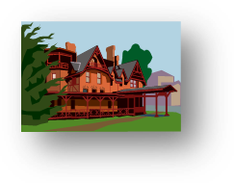

Building New Homes:
Charnwood Borough Council launched a 3-week consultation to ask people's views and comments on the latest options in meeting its target on building new homes. The Borough of Charnwood has a requirement to build 17,380 new homes between 2006 and 2028. The Council has already given permission to, or completed, 7,671 of that total and officers have previously recommended a further 6,250 homes to be provided in 2 Sustainable Urban Extensions. That still leaves 3,459 properties to plan for.
COUNCIL TAX 2015/16:
Charnwood Borough Council is responsible for collecting Council Tax from all residents across the Borough; this also includes collecting on behalf of Leicestershire County Council, the Leicestershire Fire & Rescue Service, Leicestershire Police and local Town and Parish Councils. The team pays Housing Benefit and Council Tax Support to 18000 residents and also collects Business Rates from shops and businesses. Business rates are based on the rateable value of the business premises, and this is determined by the Valuation Office Agency. Council Tax and benefit services are administered on behalf of the Council by Capita.
For 2015/16 the Fire Authority, Police and Leicestershire County Council have increased their charge by 1.99%. The Annual Council tax bills only have the capacity to display to one decimal place so this will show as an increase of 2.0%. Charnwood Borough Council has decided not to increase their part of the Council Tax for another year.
In conclusion:
Listed here are just some of the issues that I have been dealing with on behalf of residents, and the village as a whole:
- Planning Issues and Appeals
- Working with the Police and other Agencies in relation to anti-social behaviour as well as neighbourly disputes
- Home Repairs
- Village repairs: Cleansing/Road Drainage/Street & Road Signage, etc.
- Graffiti Removal
- Parking issues
- Dog Fouling
- Keeping residents regularly informed via the Long Furrow Magazine and monthly reports to the Parish Council
- Administration Assistant to the Parish Clerk
- Supporting events happening in the village & St. Hilda’s Church, e.g., Remembrance Sunday/Investiture of the new Vicar, Revd. Tim Day, etc.
Update on Committee/Panel Membership: Past & Present;
- East Goscote Village Hall Management Committee
- East Goscote Library Management Committee
- CBC Code of Conduct Committee
- CBC Member Reference/Member Development Committee
- CBC Section 106 Panel
- CBC Highways (reserve)
- CBC Overview Scrutiny Committee
- CBC Policy Scrutiny Committee
- CBC Regulatory Committee
- GCR/Council Liaison Panel
- Licensing Committee
Plus other Committees/Panels/Sub Committees over the years!
It is my hope that after these upcoming May elections I am fortunate enough to continue to be your Borough Councillor and that working together we can make this village the envy of Leicestershire!
Cllr. Cathy Duffy

