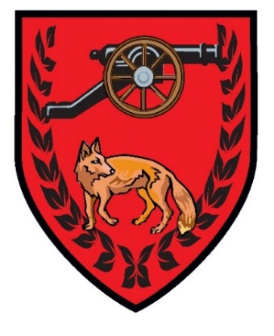
EAST GOSCOTE PARISH COUNCIL

Rules for the use of the Tennis Court,
Long Furrow, East Goscote

- Application for the use of the tennis court is open to all.

- An application form, available from the Parish Office, must be completed and a fee of £5 for Residents, £8 for Non-Residents must be paid at this time. No further fee is required.
- Any misuse of the booking system or the court will result in the membership being withdrawn, and no further booking will be allowed on this membership.
- The court can be booked in one hour periods, with a maximum of two consecutive hours. Bookings can be made no more than two weeks in advance.

- Booking of the court must be made through the Parish App. Details of this are available from the office when completing the application form.

- Appropriate footwear only allowed on the court. NO FOOTBALL BOOTS.

- Under 11s must be accompanied by an adult.
- Priority reservations will be given to Broomfield Primary School during term time.

- For safety reasons the Parish Council reserve the right to close the court during periods of inclement weather.

YOU WILL BE LIABLE FOR ANY DAMAGE INCURRED IF YOU DO NOT ENSURE THE COURT IS SECURE AFTER USE, EVEN IF THERE ARE PEOPLE WAITING TO PLAY.

Liz Pizer, Clerk

Dear Tennis Members

The Parish Council are pleased to announce the launch of their Mobile app which can be used on I phones, Android phones, and tablets.

Why a parish app?
It’s a fact that more adults use mobile apps and access the internet from mobile devices; this inspired the Parish Council to harness the power of mobile in providing information and services that are more accessible and convenient for all.
The app will be interactive with key functions to allow access to information ‘on demand’, so residents can engage with parish representatives and the local community, whilst ‘on the go’ or in the comfort of their own home.
In essence, the Parish app is a great opportunity for residents to connect, be informed, book facilities, share news and promote local events, bringing the community together.
Great features include the ability to instantly submit a photo via the app of local events or report issues in your community. Stay in the loop with instant notifications of local news and events. Also, stay updated with what’s going on at the village hall.
The app also allows you to view council meetings, planning applications, village contacts and read copies of our Long Furrow magazine, plus much more.

As a Tennis Member, you can now book your tennis courts via the app, without the need to ring or visit our website. The app will inform the parish council of your booking, which is only bookable if the slot is highlighted and therefore available. The process for this is set out below:

- Download the App
- Go to the section headed “more”
- Tap “tennis members booking”
- Create an account and input your email, password, tel etc – the tap “Register”
- Tap Schedule Reservation
- Tap Tennis Courts
- Tap Court 1 book it
- Select date and time (if it is not highlighted it will already be booked)
- Tap Book
- Tap Confirm

The parish council will be directly informed of your booking. You should receive a reply email giving you details of the court code. PLEASE CHECK YOUR SPAM.

PLEASE NOTE THE COURT MAY NOT BE AVAILABLE ALL WINTER – THE NET WILL BE REMOVED IN PERIODS OF BAD WEATHER. WE WILL NOTIFY YOU VIA THE APP WHEN THE COURT IS CLOSED – PLEASE ALLOW NOTIFICATIONS

Download the app now... spread the word and get connected!

SEARCH “EAST GOSCOTE PARISH COUNCIL”

See the attached poster for more information.

“Better communication leads to better communities. Engaging in local events, sharing news and ideas, helps make a better neighbourhood.”

