EAST GOSCOTE VILLAGE HALL

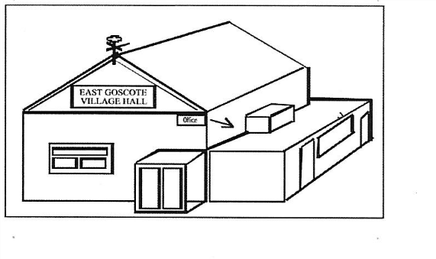
Figure 1illustration of hall
East Goscote Village Hall
Management Committee
Long Furrow
East Goscote
Leics
Phone 0116 260 2202
Latest contact options, see: https://eastgoscotepc.org.uk/contact/

Data regulations are changing. In order to prepare for the changes, we need your permission to continue to hold your personal data and inform you of your individual rights under the new legislation. We require you to opt in to allow us to hold and maintain your personal data.

We are required to hold certain information in order to fulfil our service and obligations. We will hold your Name, Address, Contact number and email address.

I am happy for you to hold and maintain my personal data

APPLICATION TO BOOK THE HALL

NAME:
ADDRESS:
POSTCODE:
TEL NO:
EMAIL:
DATE REQUIRED:
TIME (this includes set up and clean up): |  |  |  | FROM: |  |  | TO:
I have received terms & conditions relating to the Hall & Castle (if required)
Signed: |  |  |  |  | Date:
ALL PAYMENTS MUST BE IN CASH
REFUNDABLE DAMAGE WAIVER: |  |  | £40
BOUNCY CASTLE:
FULL COST REQUIRED BY WEEK PRIOR TO PARTY: |  |  |  |  |  | £
Figure 2 booking form as table
Any cancellations of less than 7 days before the booking will incur an admin charge of £15

THE COMMITTEE’S DECISION IS FINAL

Office opening times, see: https://eastgoscotepc.org.uk/contact/

